- Configure VPC peering in cross regions.
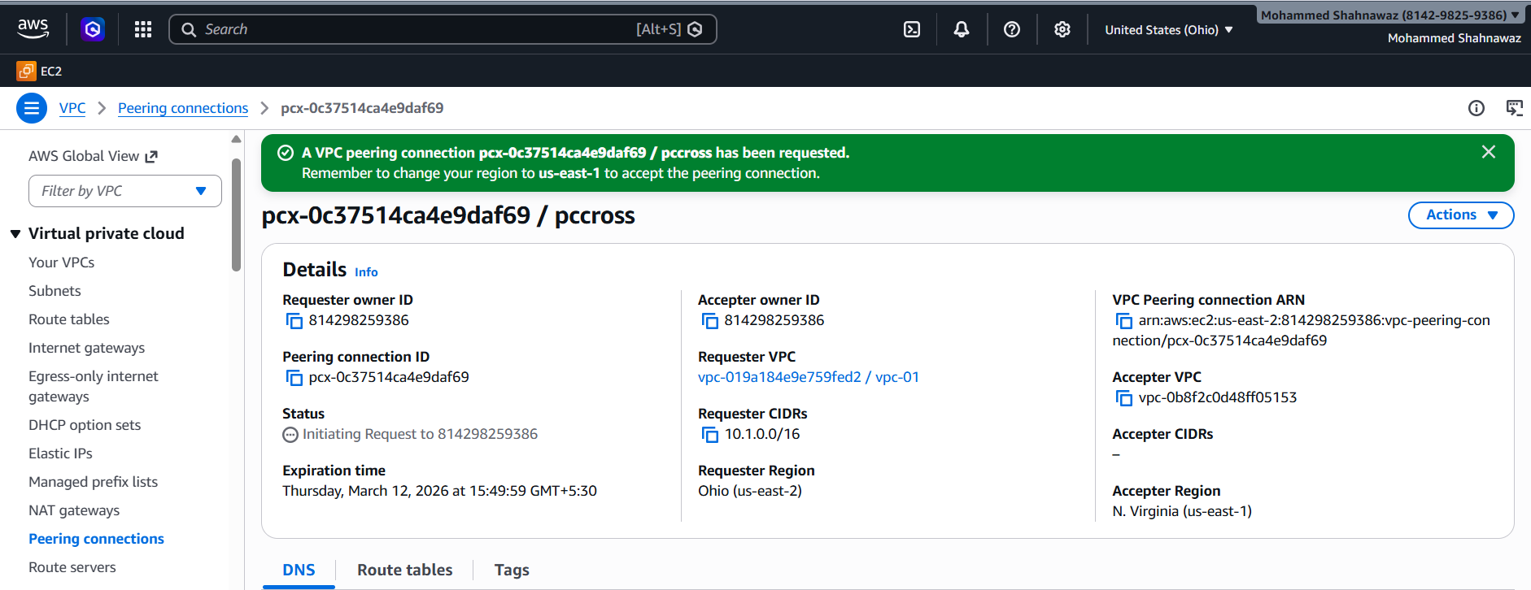
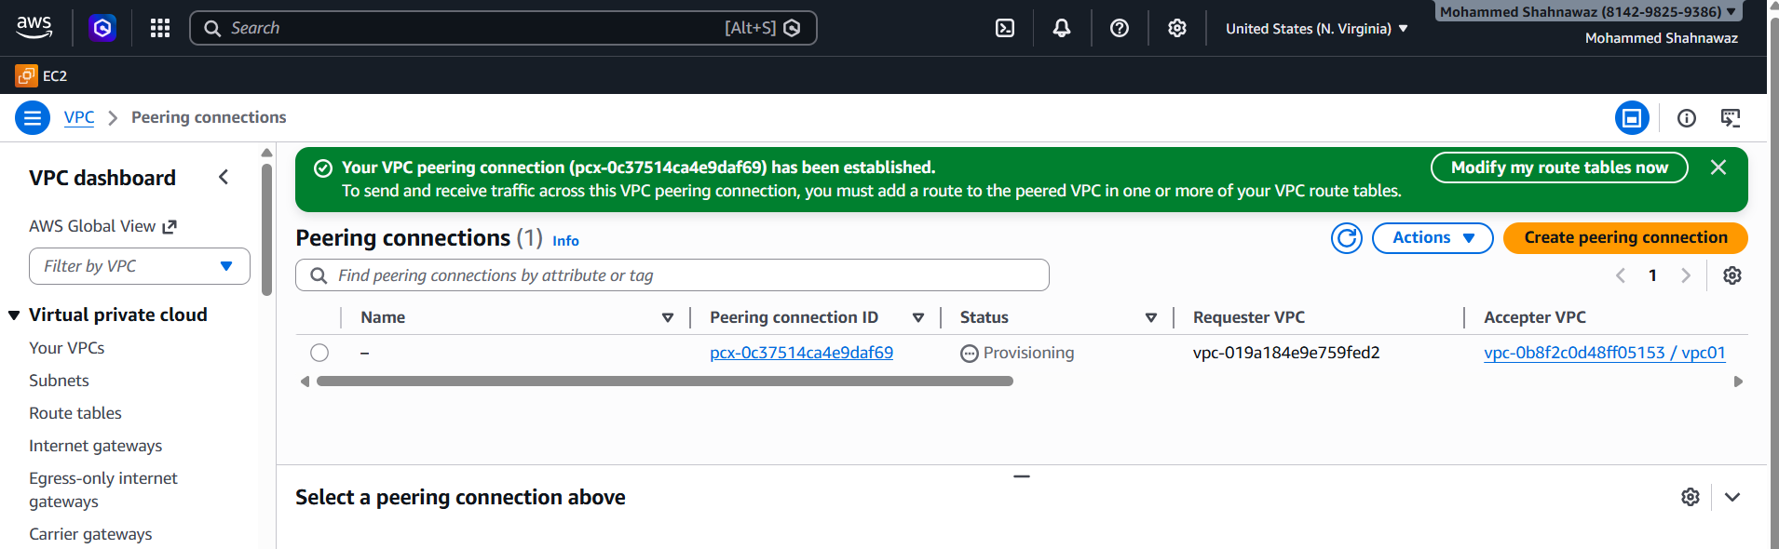
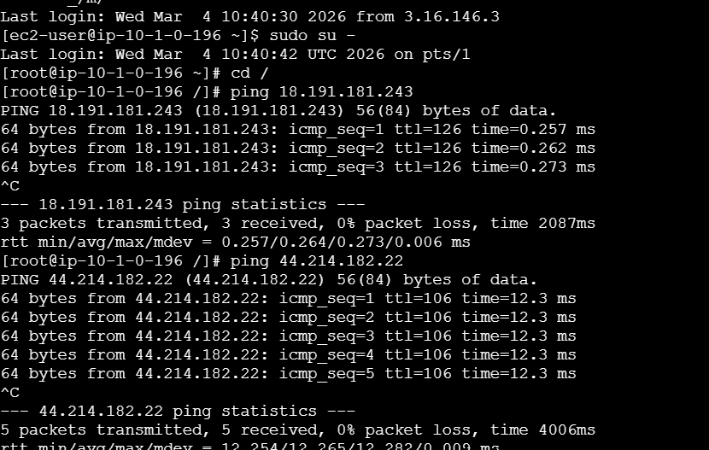
- Purchase one domain from GoDaddy.
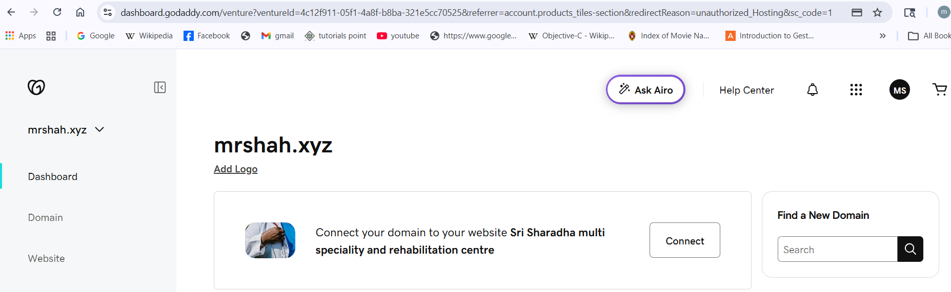
- Deploy static website in S3.
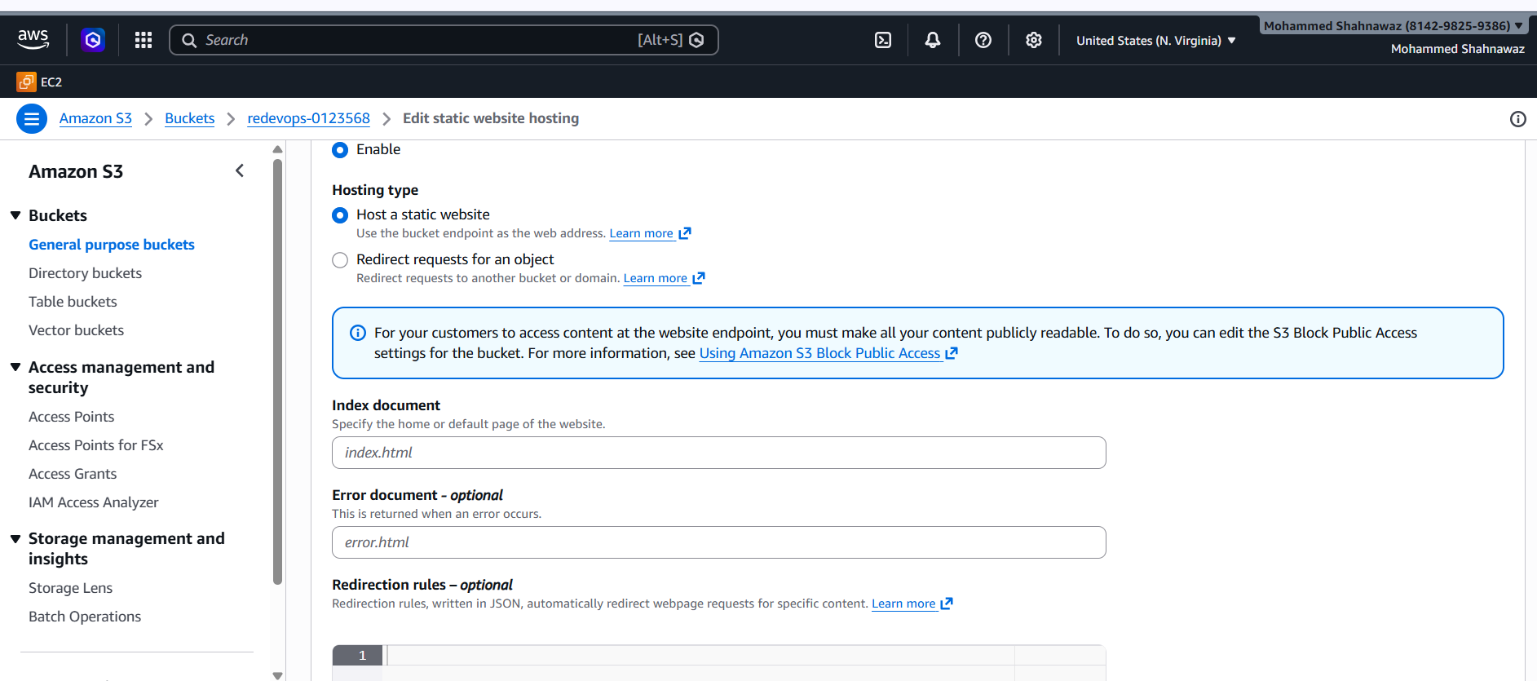
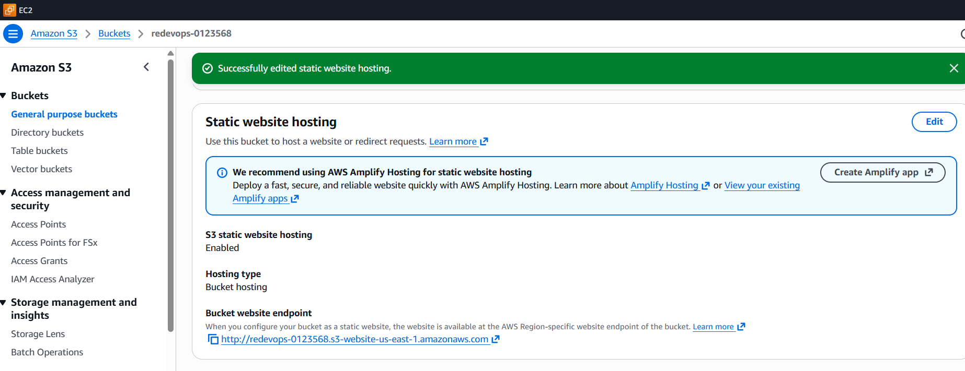
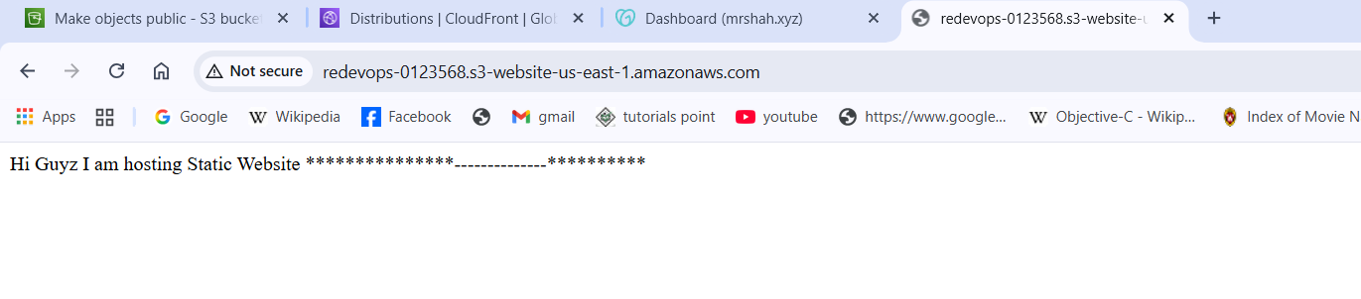
- Create a CDN and attach one SSL certificate.
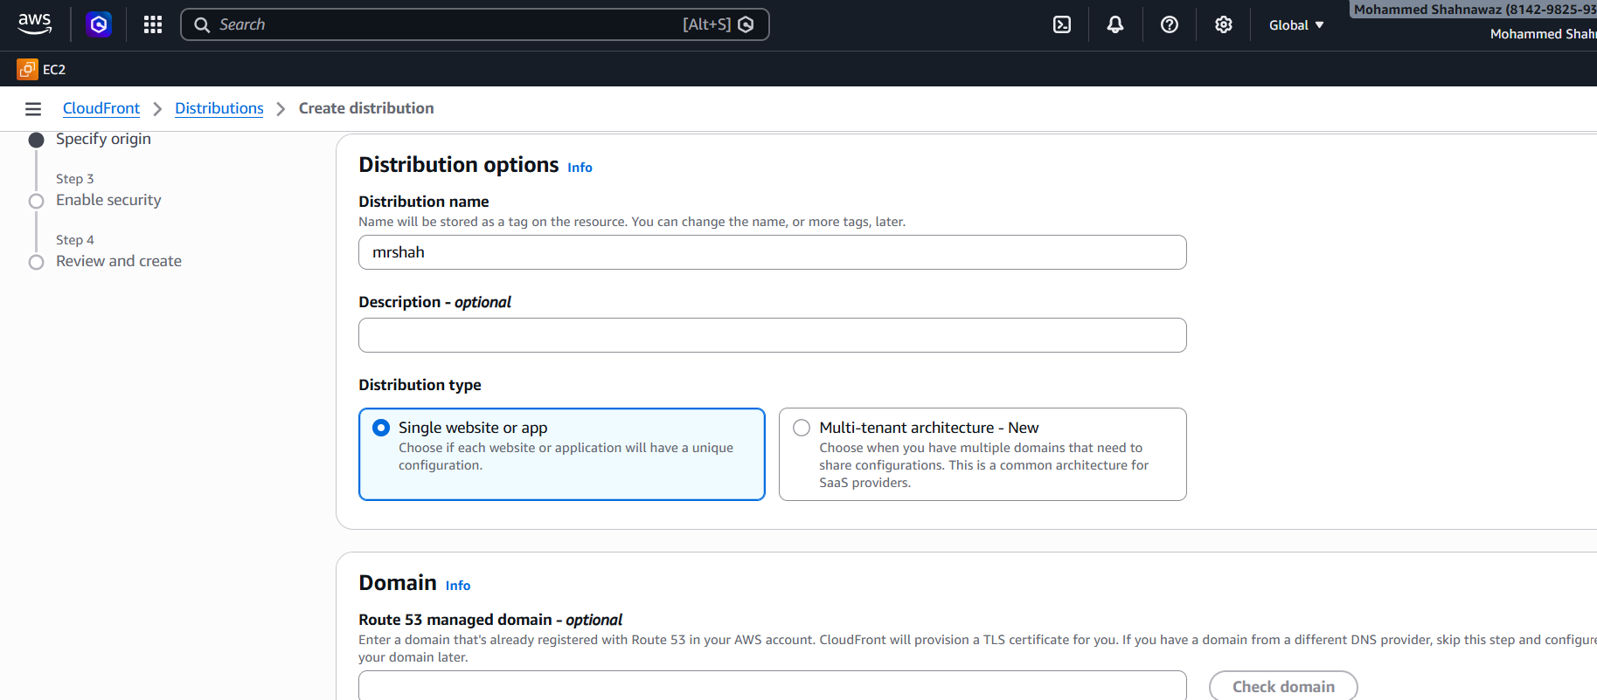
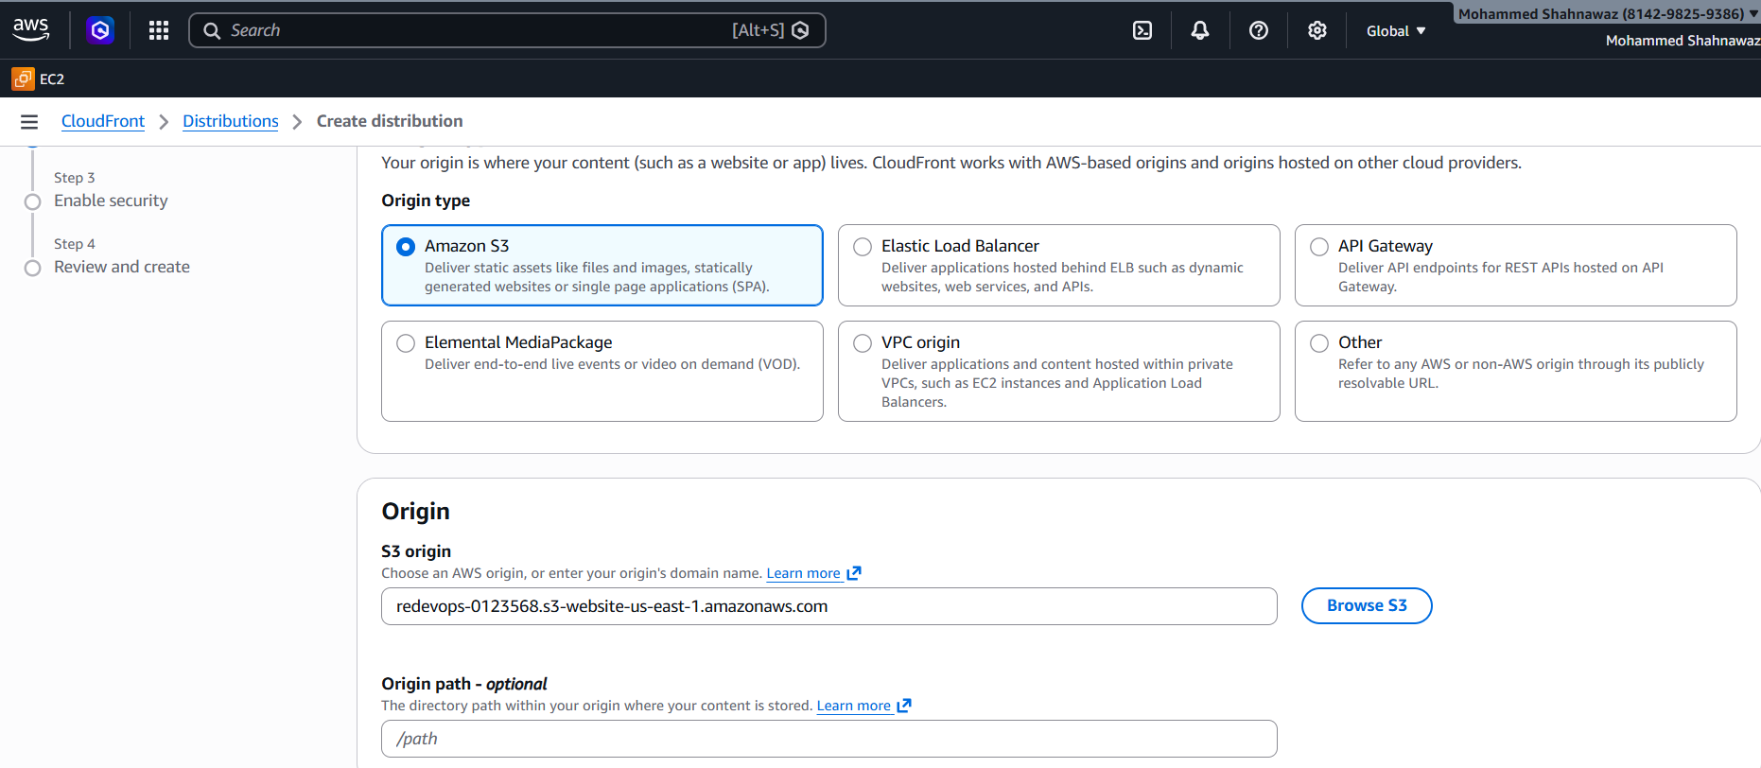
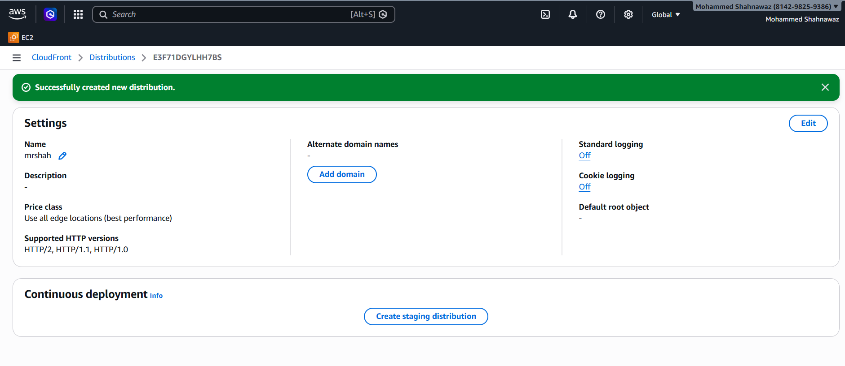
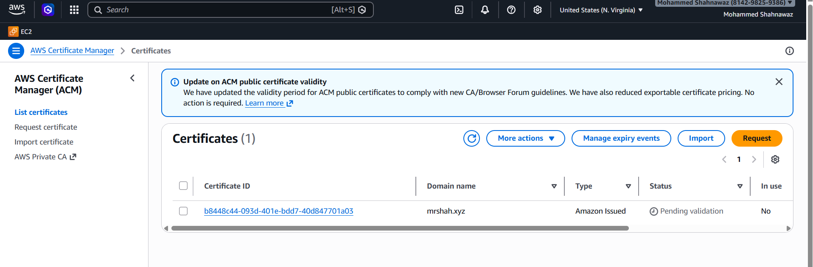
- Create a Route 53 hosted zone and map the domain with the CDN.
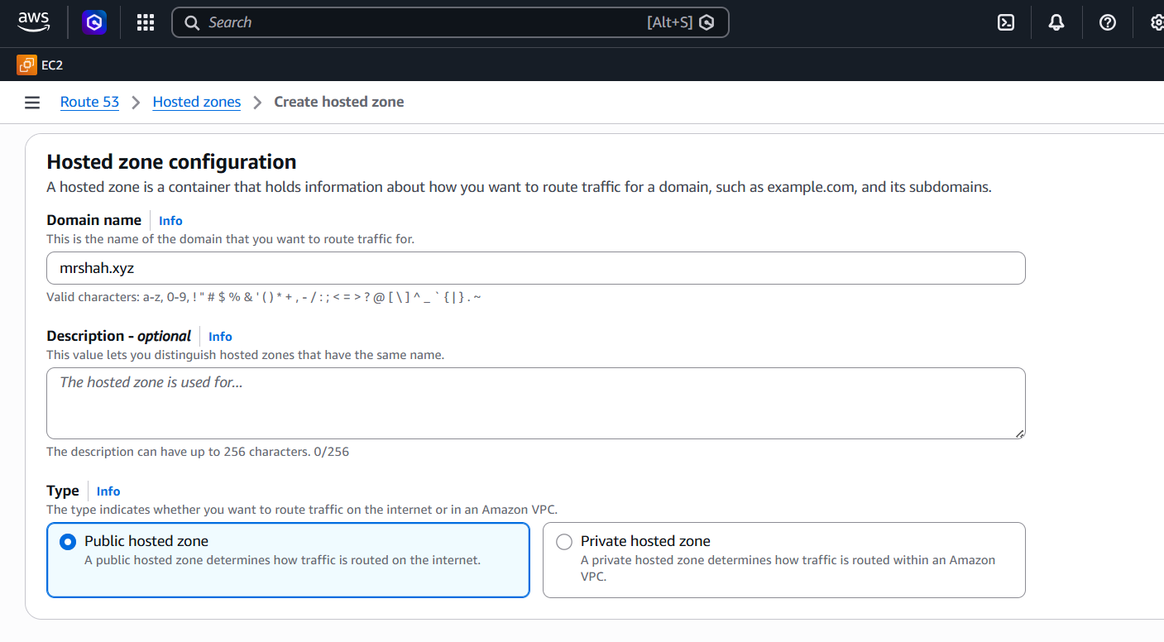
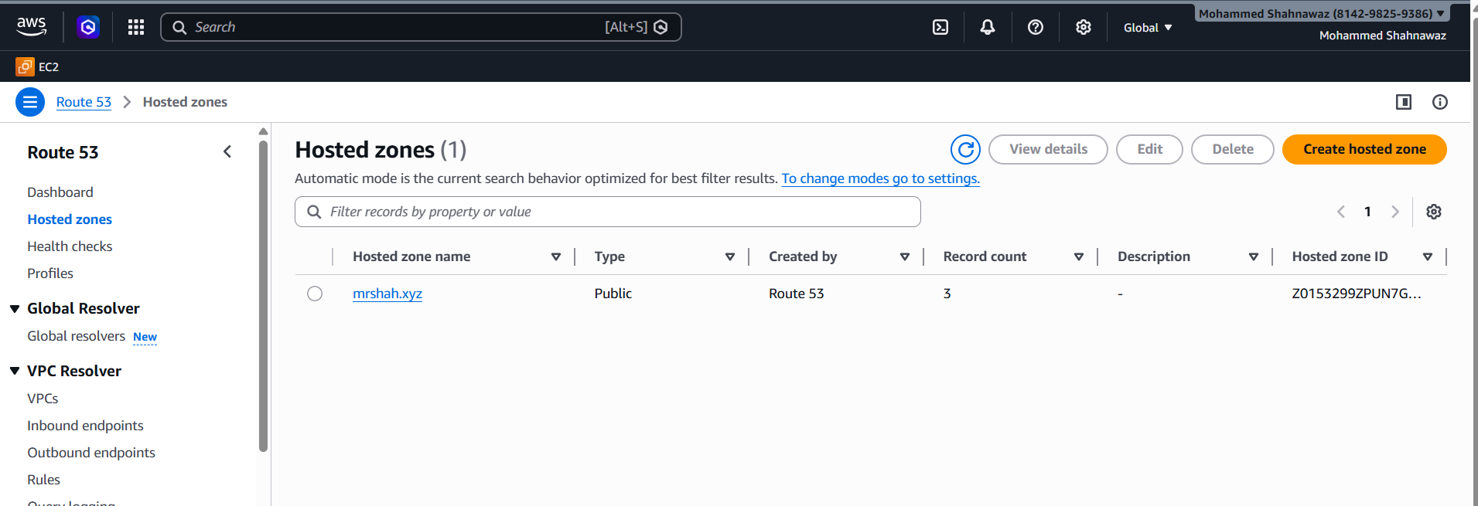
- Update the index.html in the S3 bucket and ensure the updated file is accessible using the domain name.
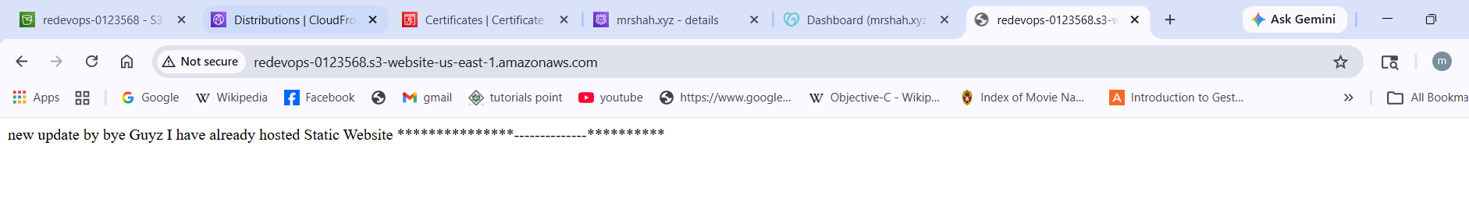
- Share the domain name in Slack to test the connectivity.
www.mrshah.xyz
mrshah.xyz

